MANDATORY DISCLOSURE

**1. Name and Address of the Institution:**

|  |  |
| --- | --- |
| Name | SRI SHANMUGHA COLLEGE OF ENGINEERING AND TECHNOLOGY |
| Address | Permanent Location as approved by AICTE |
| Post | Pullipalayam, Morur (PO) |
| Taluk | Sankari |
| District | Salem |
| Pin Code | 637 304 |
| State | Tamilnadu |
| Phone No. with STD Code | 04283 - 262999 |
| Fax No. | 04286 - 261799 |
| E-Mail | [principal@shanmugha.edu.in](mailto:principal@shanmugha.edu.in) |
| Web site | [www.shanmugha.edu.in](http://www.shanmugha.edu.in) |
| Nearest Railw a y Station | Sankari , 3 km |
| Nearest Airport (Dist in Km) | Coimbatore: 120 km Salem : 48 Kms |

**2. Name of the Organization running the institution:**

|  |  |
| --- | --- |
| Name of the organization running the Institution | SRI SHANMUGHA EDUCATIONAL CHARITABLE TRUST |
| Type of the organization | T rust |
| Address of the organization | 106 - D Sanakari Main Road,  Seetharam palayam ,  Tiruchengode,- 637 209 |
| Registered with | Sub Registrar Office,  Sankari, Salem District |
| Registration date | 24.12.2010 |
| Website of the organization | [www.shanmugha.edu.in](http://www.shanmugha.edu.in) |

**3. Name of the Principal / Director:**

|  |  |
| --- | --- |
| Name of the Principal | Dr. M. Sudha |
| Exact Designation | Principal |
| Phone number with STD Code | 914283 262999 |
| FAX number w ith STD Code | 914283 261799 |
| Email | [principal@shanmugha.edu.in](mailto:principal@shanmugha.edu.in) |
| Highest Degree | Ph.D. |
| Field of Specialization | Embedded systems |

**4. Name of the Affiliation University**

|  |  |
| --- | --- |
| Name of the affiliation University | ANNA UNIVERSIT Y, CHENNAI |
| Address | Anna University Chennai – 600 025 |
| Website | [www.annauniv.ac.in](http://www.annauniv.ac.in) |
| Latest affiliation period | One year (2019-20) |

**5. Governance**

**A. Members of the Board and their Background**

|  |  |  |
| --- | --- | --- |
| S. No | Member | Designation |
|
| 1 | Thiru.K.Shanmugham, Chairman,  Sri Shanmugha College of Engineering and Technology. | Chairman |
|
| 2 | Er.S.Prabahar, Vice Chairman, Sri Shanmugha College of Engineering and Technology | Vice Chairman |
|
| 3 | Mrs.S.Kaliyammal, Trustee, Sri Shanmugha College of Engineering and Technology | Trust Member |
|
| 4 | Dr.M.Kantha Babu, DIrector CIPR, College of Engineering Guindy, Anna University Chennai. | Academician |
|
| 5 | Dr.R.Kumaravelan , Professor & Head, Department of Mechanical Engineering, Vellalar College of Engineering and Technology. | Academician |
|
| 6 | Mr.T.T.Paranthaman, Managing Director, PRD Groups of Company, Tiruchengode. | Industry Member |
|
| 7 | Mr.V.Nataraja Perumal, Assistant Manager HR, Mold Master, Coimbatore. | Industry Member |
|
| 8 | Dr.M.Sakthivel, Assistant Professor, Mechanical Engineering, Anna University, Regional Centre Coimbatore. | Anna University Nominee |
|
| 9 | Mr.K.Mohan, Assistant Professor, Department of Civil Engineering, Sri Shanmugha College of Engineering and Technology. | Faculty Member |
|
| 10 | Dr. S.Markkandeyan, Professor, Department of Computer Science and Engineering, Sri Shanmugha College of Engineering and Technology. | Faculty Member |
| 11 | Dr. M. Kannan, Professor& Head, Department of ECE Sri Shanmugha College of Engineering & Technology. | Faculty Member |
| 12 | Dr.K.B.Nagashanmugham, Professor, Department of Science and Humanities, Sri Shanmugha College of Engineering and Technology. | Faculty Member |
| 13 | Mr.R.Boopathi, Assistant Professor, Department of Mechanical Engineering, Sri Shanmugha College of Engineering and Technology. | Faculty Member |
|
|
| 14 | Dr. M.Sudha, Principal, Sri Shanmugha College of Engineering and Technology. | Member Secretary |
|

**B. Members of Academic Advisory Body**

|  |  |  |
| --- | --- | --- |
| **S. No** | **Name** | **Designation** |
|
| 1 | Dr. M.Sudha, Principal,  Sri Shanmugha College of Engineering &Technology. | Principal |
| 2 | Dr. S.Markkandeyan, Professor,  Sri Shanmugha College of Engineering &Technology. | HOD/CSE |
| 3 | Dr.M.Kannan, Professor & Head,  Sri Shanmugha College of Engineering &Technology. | HOD/ECE |
| 4 | Mr.S. Narasimhan, Professor & Head, Sri Shanmugha College of Engineering & Technology. | HOD/Mech |
| 5 | Mr.K.Mohan, Assistant Professor,  Sri Shanmugha College of Engineering &Technology. | HOD/Civil |
|
| 6 | Mr.A.Murugananth, Assistant Professor,  Sri Shanmugha College of Engineering &Technology. | HOD/Agri |
| 7 | Dr.K.B.Nagashanmugham, Professor & Head,  Sri Shanmugha College of Engineering &Technology. | HOD/ S&H |

**C. Frequently of the Board Meeting and Academic Advisory Body**

* Frequency of the Board Meeting : Every Year
* Frequently of Academic Advisory Body : Once in Every Semester

**D. Organizational Chart and Processes:**

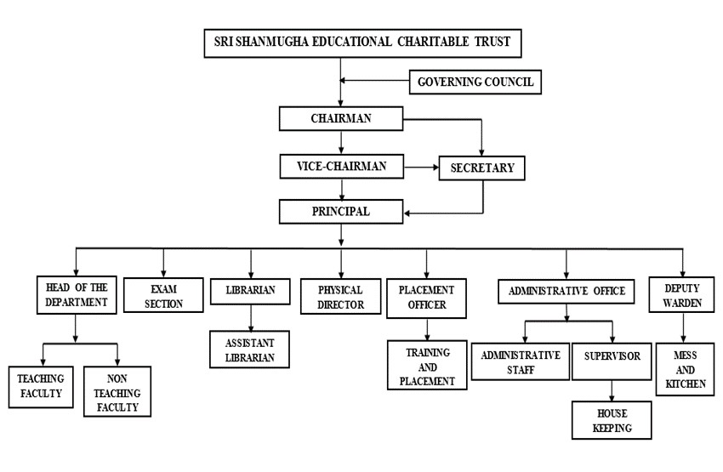

**E. Involvement of Faculty / Students in Academic Affairs / Improvement:**

|  |  |
| --- | --- |
| Faculty | The faculty members are encouraged to pursue higher studies (Ph.D.), to upgrade their qualification & skills. They also attend NPTel, FDP, workshops, conferences & seminars to enrich the knowledge to catch up with the state-of-the- art technologies. |
| Students | The students meet the faculty members regularly and HOD’s of the respective departments twice in a week through the student’s council, which facilitates free exchange of ideas from the students with regard to the improvements and performance |

**F. Mechanism / Norms and Procedure for Democratic / Good Governance**

The students are appraised with regard to their performance through a uniquely designed format. This format works by a self-evaluation process by the students concerned in which the students make projection of their anticipated performance before a particular examination. The actual performance in the examination is compared with the projection and their deviations are evaluated. This helps the students to address the weak areas and make corresponding improvements. The students are taken care of an internal system, in which a group of 15 students are closely interacted with a staff member who in turn will counsel them in-depth and solve their problems smoothly.

**G. Student Feedback on Institutional Governance / Faculty Performance**

Students are encouraged to express their grievances through a feedback form made for this purpose. This feedback is collected twice in a semester on regular basis. Besides, the students can also directly approaches the principal in case of any of problems are not being met out fruitfully.

**H. Grievance Redressal Mechanism**

System for Redressal of grievances of faculty, staff and students. The management of the college follows an open system of administration and grievances from staff and students are given the utmost attention. Complaints and suggestion boxes are kept at a number of places in the campus and also in the hostels. The suggestions and complaints are carefully looked into and remedial measures undertaken. Responses are also published through notice boards.

|  |  |
| --- | --- |
| Students | The Chairman once a month and the Principal Twice a month meet the students directly and enquire them regarding the faculty performance, infrastructure, placement and training activities and other facilities required. Students at any point of time can meet the Chairman / Correspondent to get solved for any of their problems |
| Faculty | The Chairman once a month and the Principal once a week meet the faculty directly through staff meeting to redress any grievance that may be brought by the faculty with regard to facilities provided to them and improvements in infrastructure to be established for better teaching methods and techniques. |

1. **Establishment of Anti Ragging Committee**

**Anti-Ragging Committee**

|  |  |  |  |  |  |
| --- | --- | --- | --- | --- | --- |
| S. No | Name | Position | Present/ Designation | Mobile Numbers | Email - id |
|
| 1 | Dr.M.Sudha | Chairman | Principal | 7373696999 | principal@shanmugha.edu.in |
| 2 | Mr.S.Hariharan | Member | Sub Inspector | 9498167740 | krishnanlogin@gmail.com |
| 3 | Mr.K.Arulkumar | Member | Thasildar | 9445000554 | thasildarsankari@gmail.com |
| 4 | Mr.C.Parameshwaran | Member | Reporter | 9842479194 | dailythanthiparamesh@yahoo.com |
| 5 | Mr.R.Saravanan | Member | Parent | 9787310440 | Nagarajurajan555@gmail.com |
| 6 | Mr.S.Nagaraju | Member | Boy student | 9787310440 | Nagarajurajan555@gmail.com |
| 7 | Ms.S.Haripriya | Member | Girl Student | 9865420835 | Haripriyaece89@gmail.com |
| 8 | Mr.R.V.Dinesh | Others | A.O | 7373672999 | rvddinesh@shanmugha.edu.in |

**Anti – Ragging Squad**

|  |  |  |  |  |  |
| --- | --- | --- | --- | --- | --- |
| **S.No** | **Name** | **Position** | **Present/ Designation** | **Mobile Numbers** | **Email - id** |
|
| 1 | Dr.M.Sudha | Chairman | Principal | 7373696999 | principal@shanmugha.edu.in |
| 2 | Dr.K.Kannan | Member | HoD/ECE | 9965929691 | hod.ece@shanmugha.edu.in |
| 3 | Mrs.K.Meenambika | Member | AP/Maths | 9715829999 | kmeenambika@shanmugha.edu.in |
| 4 | Mr.K.Mohan | Member | AP/CIVIL | 9677749250 | mohank@shanmugha.edu.in |
| 5 | Dr.K.B.Nagashanmugham | Member | HoD/S&H | 9994458450 | Hod.sandh@shanmugha.edu.in |
| 6 | Ms.M.Dhivyaa | Member | AP/ECE | 7708687905 | Dhivyaa.ece@shanmugha.edu.in |

**J. Establishment of Online Grievance Redressal Mechanism**

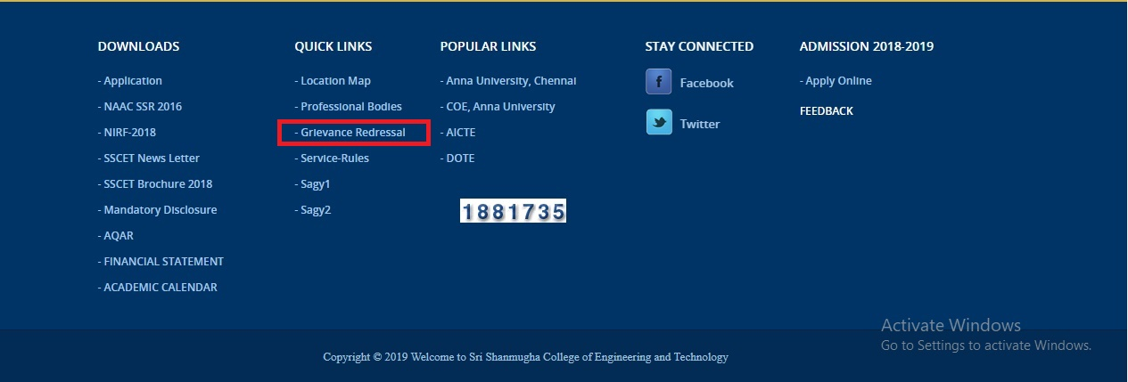

**K. Establishment of Grievance Redressal Committee in the Institution and Appointment of OMBUDSMAN by the University**

|  |  |  |  |
| --- | --- | --- | --- |
| Sl.No | Name | Department | Designation |
| 1. | Dr.M.Sudha | Principal | Convener |
| 2. | Dr.S.Markkandeyan | HOD\CSE | Member |
| 3. | Mr.K.Mohan | AP\Civil | Member |
| 4. | Dr.M.Kannan | HOD\ECE | Member |
| 5. | Mr.R.Boopathi | HOD\MECH | Member |
| 6. | Dr.K.M.Nagashanmugam | Prof\S&H | Member |
| 7. | U. Varshasri | ECE\Student | Member |
| 8. | S.Sharmila | Civil \ Student | Member |
| 9. | S. Varunbhirabhu | Mech \ Student | Member |
| 10. | P.Harini Gayathri | Agri \ Student | Member |

**L. Establishment of Internal Complaint Committee (ICC)**

|  |  |  |  |
| --- | --- | --- | --- |
| Sl.No | Name | Department | Designation |
| 1. | Prof. K. Meenambikai | AP/ S & H | Member |
| 2. | Dr. S. Markkandayan | Prof. & HOD/ CSE | Member |
| 3. | Mrs. V.Amasavalli | Lab Technician | Staff Member |
| 4. | MS. R.Priya | Lab Technician | Staff Member |
| 5. | Ms. P Saranya | IV Mech. | Student Member |
| 6. | Ms. A. Rajeswari | IV ECE | Student Member |
| 7. | Mr.M. Jagadesan | IV Civil. | Student Member |

**M. Establishment of Committee for SC/ST**

|  |  |  |  |
| --- | --- | --- | --- |
| **S.No** | **NAME** | **DESINGNATION** | **POSITION IN THE COMMITTEE** |
| 1. | Dr.M.Sudha | Principal | Chair person |
| 2. | Dr.S.Markkendayan | Vice principal | Convener |
| 3. | Dr.M.Kannan | HoD\ECE | Member |
| 4. | Dr.K.M.Nagashanmugam | HoD|S&H | Member |
| 5. | Mr.R.Boopathi | AP\ Mech | Member |
| 6. | Ms.M.Chitra | AP\ Civil | Member |

**N. Internal Quality Assurance Cell (IQAC)**

**6. Programme.**

|  |  |  |  |  |  |  |  |  |
| --- | --- | --- | --- | --- | --- | --- | --- | --- |
| **Name of the Programme** | **B.E Agri** | **B.Tech**  **AI&DS** | **B.E CSE** | **B.E**  **ECE** | **B.E**  **Mech** | **B.E**  **Bio** | **B.Tech**  **IT** | **M.E CSE** |
| Approved by AICTE | Yes | Yes | Yes | Yes | Yes | Yes | Yes | Yes |
| Accredited by AICTE | Yes | Yes | Yes | Yes | Yes | Yes | Yes | Yes |

1. **Status Accreditation of the Courses**

No of Course: UG – 7, PG – 1

No of courses Accredited : **01 ECE**

No of Course Applied for Accreditation : **2 (CSE & Mech)**

Status of Accreditation : All the three Courses Accredited

|  |  |  |
| --- | --- | --- |
| **S. No** | **Members** | **Designation** |
| 1 | Dr. M.Sudha | Principal( Chair Person) |
| 2 | Mr. R. Boopathi | Assistant Professor of Mechanical (Overall Coordinator) |
| 3 | Mr.K.Mohan | Assistant Professor of Civil |
| 4 | Dr.A.Vaniprabha | Associate Professor of ECE |
| 5 | Mr.S.Nirmal Kumar | Assistant Professor of Mechanical |
| 6 | Ms.Manimala | Assistant Professor of Mathematics |
| 7 | Mr.R.Palanivel | Assistant Professor of CSE |
| 8 | Mr. K. Balaji Vasenth | Secretary |
| 10 | Dr. R. Rajavel | Local Society,  Kongu Nursing Home, Tiruchengode |
| 11 | 1. Ms. M. Sathya 9442346546  2. Mr. A. Krishnan 9042669873 | Alumni |
| 12 | 1. Ms. N. Vivetha (732715106015)  2. Mr. S. Ashok (732715106707) | Student |
| 13 | Mr. T. T. Paranthaman | Industrialists |
| 14 | Dr. R. Kumaravelan | External Expert |

|  |  |  |  |  |  |
| --- | --- | --- | --- | --- | --- |
| **Name of the programme** | **Number of Seats** | **Duration (Years)** | **Fees** | | **Placement facilities** |
| **MQ** | **GQ** |
| B.E – Agriculture Engineering | 60 | 4 | 55,000 | 55,000 | Yes |
| B.E – Civil Engineering | 60 | 4 | 50,000 | 50,000 | Yes |
| B.E – Computer Science and Engineering | 60 | 4 | 55,000 | 55,000 | Yes |
| B.E – Electronics and Communication Engineering | 60 | 4 | 55,000 | 55,000 | Yes |
| B.E – Mechanical Engineering | 60 | 4 | 55,000 | 55,000 | Yes |
| B.E-Artificial Intelligence &Data Sciences | 60 | 4 | 55,000 | 55,000 | Yes |
| B.E-Bio medical Engineering | 60 | 4 | 55,000 | 55,000 | Yes |
| M.E - Computer Science and Engineering | 12 | 4 | 55,000 | 55,000 | Yes |

|  |  |  |  |  |  |  |  |
| --- | --- | --- | --- | --- | --- | --- | --- |
| **Name of the programme** | **Placement for last 3 Years** | | | **Placed Students Salary Details (Per Annum)** | | |  |
|  |
| **2015-16** | **2016-17** | **2017-18** | **Min** | **Ave** | **Max** |  |
| B.E - Agriculture Engineering | First Batch will pass out during 2019 -2020 | | | | | |  |
| B.E - Civil Engineering | 29 | 32 | 10 | 96000 | 129968 | 240000 |  |
| B.E - Computer Science and Engineering | 19 | 11 | 9 | 96000 | 224025 | 450000 |  |
| B.E - Electronics and Communication Engineering | 35 | 29 | 14 | 120000 | 275714 | 550000 |  |
| B.E - Mechanical Engineering | 90 | 66 | 39 | 94000 | 194846 | 450000 |  |
| M.E - Computer Science and Engineering | 18 | 9 | 3 | 180000 | 150000 | 300000 |  |

**7. Faculty**

**A. Permanent Faculty**

**M.E. - Computer Science and Engineering**

|  |  |  |  |
| --- | --- | --- | --- |
| **S.No.** | **Name of the faculty** | **Designation** | **Qualification** |
| 1 | Dr. Radhakrishnan R | Professor | M.E., Ph.D |
| 2 | Mrs. Vijayalakshmi K P | Assistant Professor | M.E., |
| 3 | Mrs. Dhanarani J | Assistant Professor | M.E., |

**B.E. - Computer Science and Engineering**

|  |  |  |  |
| --- | --- | --- | --- |
| **S.No.** | **Name of the faculty** | **Designation** | **Qualification** |
| 1 | Dr.S.Markkendeyan | Professor and HOD | M.E., Ph.D |
| 2 | Dr. Shobhana B | Associate Professor | M.E., Ph.D |
| 3 | Mr. U.Muthaiah | Assistant Professor | M.E., |
| 4 | Dr.Salem Jeyaseelan W R | Associate Professor | M.E., (Ph.D) |
| 5 | Mr. S.K.Murugaraja | Assistant Professor | M.E., |
| 6 | Ms.J.Karthikeyan | Assistant Professor | M.E., |
| 7 | Mr.P.KameshKumar | Assistant Professor | M.E., |
| 8 | Ms. S.P.Ramya | Assistant Professor | M.E., |
| 9 | Mrs.S. Arthi | Assistant Professor | M.E., |
| 10 | Ms.Gnanapriya P | Assistant Professor | M.E., |
| 11 | Mr. B.Givindaraju | Assistant Professor | M.E., |
| 12 | Mr. A. Ramamoorthy | Assistant Professor | M.E., |

**B.E. – Mechanical Engineering**

|  |  |  |  |
| --- | --- | --- | --- |
| **Sl.No.** | **Name of the faculty member** | **Designation** | **Qualification** |
| 1 | Dr.Narasimhan V | Professor | M.E., Ph.D |
| 2 | Dr.L.Prabu | Associate Professor | M.E., Ph.D |
| 3 | Dr. Sathiyaraju. M | Associate Professor | M.E., Ph.D |
| 4 | Mr. R.Boopathi | Assistant Professor | M.E., |
| 5 | Mr.J.Mahendran | Assistant Professor | M.E., |
| 6 | Mr.N.Arul | Assistant Professor | M.E., |
| 7 | Mr. M.Kandhasamy | Assistant Professor | M.E., (Ph.D) |
| 8 | Mr. V.Kavin Raj | Assistant Professor | M.E., |
| 9 | Mr. E.Gopinath | Assistant Professor | M.E., |
| 10 | Mr.M.Mohan | Assistant Professor | M.E., |
| 11 | Mr.A.B.Chandravathanan | Assistant Professor | M.E., |

**B.E. – Electronics and Communication Engineering**

|  |  |  |  |
| --- | --- | --- | --- |
| **S.No.** | **Name of the faculty** | **Designation** | **Qualification** |
| 1 | Dr.M.Sudha | Professor & Principal | M.E., Ph.D |
| 2 | Dr. M.Kannan | Professor | M.E., Ph.D |
| 3 | Dr. A.Vaniprabha | Associate Professor | M.E.,PhD |
| 4 | Dr.K.Asan Mohideen | Associate Professor | M.E.,PhD |
| 5 | Mrs.K.Priya | Assistant Professor | M.E., |
| 6 | Ms.G.Esaiyarasi | Assistant Professor | M.E. |
| 7 | Ms.M.Dhivyaa | Assistant Professor | M.E. |
| 8 | Mr.M. Sridhar | Assistant Professor | M.E. |
| 9 | Mrs.D.Saranya | Assistant Professor | M.E. |
| 10 | Mr. R.Prabhu | Assistant Professor | M.E. |

**B.E – Civil Engineering**

|  |  |  |  |
| --- | --- | --- | --- |
| **Sl.No.** | **Name of the faculty member** | **Designation** | **Qualification** |
| 1 | Mr. P.Ramalingam | Associate Professor | M.Tech |
| 2 | Mr.K.Mohan | Associate Professor | M.E., |
| 3 | Mr. D.Logachandran | Assistant Professor | M.E. |
| 4 | Mr.K.Sathiyanathan | Assistant Professor | M.E. |

**B.E Agriculture Engineering**

|  |  |  |  |
| --- | --- | --- | --- |
| **S.No.** | **Name of the faculty** | **Designation** | **Qualification** |
| 1 | Mr.P.S.Jeganathan | Professor | B.E, M.E |
| 2 | Dr.C.Malarvizhi | Associate Professor | B.Sc, MSc & PhD |
| 3 | Mr. N.Thiyagarajan | Associate Professor | B.Sc &, M.Sc Agri |
| 4 | Mr.K.Murugesan | Associate Professor | B.Sc &, M.Sc Agri |
| 5 | Mr. A.Muruganantham | Assistant Professor | B.E.,M.E., |
| 6 | Mr. V.Gnanaprakash | Assistant Professor | B.Tech.,M.Tech |
| 7 | Mr. E.Selvam | Assistant Professor | B.Sc &, M.Sc Agri |
| 8 | Ms.G.Aruthra Devi | Assistant Professor | B.Tech.,M.Tech |
| 9 | Mr.M.Dineshkumar | Assistant Professor | B.E.,M.E., |
| 10 | Mr. R.Manikandan | Assistant Professor | B.E.,M.E., |

**Science and Humanities:**

|  |  |  |  |
| --- | --- | --- | --- |
| **S.No.** | **Name of the faculty** | **Designation** | **Qualification** |
| 1 | Dr.K.B.Nagashanmugam | Professor | M.Sc, Ph.D., |
| 2 | Dr.P.Sivakumar | Professor | M.Sc., Ph.D., |
| 3 | Dr.K.Ganesh | Associate Professor | M.Sc., Ph.D |
| 4 | Mrs. K.Nirosha | Assistant professor | M.Sc., M.Phil., |
| 5 | Mr.S.Chandrasekar | Associate Professor | M.Sc., M.Phil., |
| 6 | Dr.K. Kumar | Assistant Professor | M.Sc., Ph.D., |
| 7 | Mrs S.Priyadharshini | Assistant Professor | M.Sc., M.Phil., |
| 8 | Mrs.Saveetha | Assistant Professor | M.Sc., M.Phil., |
| 9 | Mr. T.Aasaithambi | Associate Professor | M.Sc., |
| 10 | Mr. S.Senthikumar | Assistant Professor | M.Sc., M.Phil., |
| 11 | Mrs. K.Meenambika | Assistant Professor | M.Sc., M.Phil., |
| 12 | Ms. S.Manimala | Assistant Professor | M.Sc., M.Phil., |
| 13 | Mrs.Ramya K | Assistant Professor | M.Sc., M.Phil., |
| 14 | Mr.S.Balaji | Assistant Professor | M.A., M.Phil |
| 15 | Mr.D.Johnson | Associate Professor | M.A., M.Phil |
| 16 | Mr.Ramesh A | Assistant professor | M.A., M.Phil |
| 17 | Mrs. Haritha R | Assistant Professor | M.E., |
| 18 | Mr.Surrendarkumar | Assistant Professor | M.E., |
| 19 | Mr.Kameshkumar P | Assistant Professor | M.E., |
| 20 | Mr. Mohan M | Assistant Professor | M.E., |
| 21 | Mr. S. Nirmalkumar | Assistant Professor | M.E., |
| 22 | Ms.P.Gnanapriya | Assistant professor | M.E., |

1. **Adjunct faculty**
2. **Dr.Kumar Rajamani Senior Architect, Infosys Ltd, Bengaluru**
3. **Permanent Faculty : Student Ratio**

|  |  |  |
| --- | --- | --- |
| **Name of the Course** | **Total Sanctioned Students** | **Permanent Faculty : Students Ratio** |
| B.E - Agriculture Engineering | 180 | 1:18 |
| B.E - Civil Engineering | 60 | 1:15 |
| B.E - Computer Science and Engineering | 180 | 1:20 |
| B.E - Electronics and Communication Engineering | 180 | 1:18 |
| B.E - Mechanical Engineering | 180 | 1:18 |
| B.Tech Artificial Intelligence and Data Science | 60 | 1:20 |
| B.E Biomedical Engineering | 60 | 1:20 |
| B.Tech Information Technology | 60 | 1:20 |
| M.E - Computer Science and Engineering | 36 | 1:12 |

**8. Principal Profile**

**Name :** Dr. M.Sudha

**Date of Birth :** 30.05.1972

**Unique ID :** 1-3369345174

**Educational Qualification:**

|  |  |  |  |
| --- | --- | --- | --- |
| **Degree** | **Specialization** | **University** | **Year of Passing** |
| B.E | Electrical and Electronics Engineering | Bharathiyar University | 1993 |
| M.E | Applied Electronics | Bharathiyar University | 2004 |
| Ph.d | Electrical Engineering | Anna University | 2009 |

**Working Experience:**

**Teaching:** 24 Years 8 Months

**Research:** 15 Years

**Industry:** Nil

**Area of Specialization:** Electronics and Communication Engineering

**Research Guidance:**

|  |  |
| --- | --- |
| National Journal | 8 |
| International Journal | 17 |
| National Conference | 12 |
| International Conference | 18 |
| Master Guided | 25 |
| Ph.D. | 4 |

**No of Books Published:** 2

**9. Fee**

**A. Details of fee, as approved by state fee committee for Govt.Quota**

|  |  |  |
| --- | --- | --- |
| **Course** | **Govt.Quota** | **Mgt. Quota** |
|
|
| B.E / B.Tech | Rs.50,000/- | Rs.85,000/- |
| B.E / B.Tech  Accredited | Rs. 55,000/- | Rs. 87,000/- |
| M.E | Rs.50,000/- | Rs.50,000/- |

**B. Time Schedule for Payment of Fee for the Entire Programme.**

Two Instalment (At the commencement of each semester)

**C. No of Fees Waiver Granted with amount:**

No of Fee Waiver Granted : 308

Amount, the fees Waiver Granted : 6598400

**D. Number of Scholarship Offered by the**

**Institution, Duration and amount** NIL

1. **Criteria for Fee Waiver:**

* Based on Academic performance
* Financial Consideration and Based on 12th mark

**F. Estimated cost for Boarding and Lodging in Hostel:**

|  |  |  |
| --- | --- | --- |
| Description | Boys | Girls |
| Boarding and Lodging | 55,000 | 55,000 |

**10. Admission:**

|  |  |  |  |  |  |  |  |
| --- | --- | --- | --- | --- | --- | --- | --- |
|  | | **B.E Agri** | **B.E Civil** | **B.E CSE** | **B.E ECE** | **B.E Mech** | **M.E CSE** |
| **Seat Sanctioned 2019-20** | | 60 | 60 | 60 | 60 | 60 | 18 |
| **Admitted Students** | **2017-18** | 63 | 19 | 49 | 53 | 42 | 0 |
| **2018-19** | 40 | 0 | 50 | 49 | 30 | 6 |
| **2019-20** | 60 | 0 | 42 | 37 | 32 | 2 |
| **Application Received Management Quota** | **2017-18** | 113 | 27 | 59 | 57 | 43 | 13 |
| **2018-19** | 79 | 18 | 49 | 55 | 37 | 8 |
| **2019-20** | 83 | 0 | 13 | 10 | 22 | 8 |
| **Number of Admitted through MQ** | **2017-18** | 35 | 10 | 17 | 17 | 15 | 0 |
| **2018-19** | 13 | 0 | 4 | 6 | 3 | 6 |
| **2019-20** | 29 | 0 | 9 | 5 | 19 | 2 |

**11. Admission Procedure:**

**A. Mention the admission test being followed, name and address of the test agency:**

**Name of Test Agency**

**Government Quota:** Based upon the rank list published by TNEA and

Counselling conducted by Anna University.

**Management Quota:** Based upon the rank list by consortium of self-

Financiering professional Arts and Science colleges

in Tamilnadu.

**Address of Test Agency:**

**Government Quota:** Anna University, Chennai

**Management Quota:** Consortium of Self Financing Professional Arts and

Science Colleges in Tamilnadu.

**B. Number of Seats allotted to different Test Qualified candidate separately:**

**TNEA :** 65%

**TNSF Consortium :** 35%

**C. Calendar for Admission against Management /Vacant Seats:**

2020-21 Admission Tentative dates

1. Last date of request for applications : 17.08.2019

2. Last date of Submission of application : 17.08.2019

3. Date of announcement of results : 23.08.2019

4. Date of release of admission list : 26.08.2019

5. Date of admission : 01.09.2019

6. Last date of closing of admission : 04.09.2019

7. Starting of academic session : To be declared

8. Date of activation of the waiting list

on the expiry of the date of main list : After Commencement of academic

Session

9. Refund Policy : Available.

(Except Registration fees and Admission fees).

**12. Criteria and Weightages for Admission:**

**A. Description of Criteria & Weightages:**

Marks obtained in Mathematics, Physics and Chemistry of HSC Examination

**B. Minimum Level of acceptance if any:**

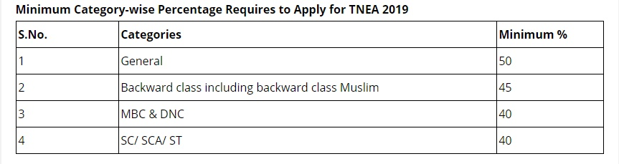

|  |  |  |  |  |  |  |  |  |
| --- | --- | --- | --- | --- | --- | --- | --- | --- |
|  | OC | | BC | | MBC | | SC / ST | |
| GQ | MQ | GQ | MQ | GQ | MQ | GQ | MQ |
| 2017 - 2018 | Nil | Nil | 182 | 145 | 181 | 123 | 192.5 | 81 |
| 2018 - 2019 | Nil | Nil | 179.5 | 145 | 182.5 | 133 | 180.5 | 158 |
| 2019 - 2020 | Nil | 180 | 182 | 176 | 174 | 152 | 148.5 | 113.5 |

**C. Cut-Off Level for Last Three Years.**

**D. Display marks Scored in Test and Aggregate for all candidates.**

Admission yet to be complete for 2020 - 21

**13. List of Applications:**

Admission yet to be complete for 2020 - 21

**14. Results of Admission under Management Seats / Vacant Seats.**

**A. Composition of Selection team for admission under MQ**

1. Mr.K.Shanmugham - Chairman

2. Mr.S.Prabahar - Vice-Chairman

3. Mr.R.V.Dinesh - Admission Officer

4. Dr.M.Sudha - Principal

**B. Score of the Individual Candidate admitted:**

Admission yet to be complete for 2020 - 21

**C. List of Candidate who have been offered admission:**

Admission yet to be complete for 2020 - 21

**D. Waiting list of candidates in order of merit:**

Admission yet to be complete for 2020 - 21

**E. Waiting list of candidates, who joined with in date, vacancy position in each category before operation of waiting list.**

Admission yet to be complete for 2020 - 21

**15. Information of Infrastructure and Other Resources Available.**

**a. Library**

**Number of Library Books/Titles/Journals available (Program-Wise)**

|  |  |
| --- | --- |
| **Volumes (S&H)** | 6358 |
| **Titles(E&T)** | 4035 |
| **Volumes (E&T)** | 21841 |

|  |  |  |
| --- | --- | --- |
|  | International Journal | National Journal |
| B.E Agri | 6 | 6 |
| B.E Civil | 6 | 6 |
| B.E CSE | 6 | 6 |
| B.E ECE | 6 | 6 |
| B.E Mech | 6 | 6 |
| M.E CSE | 6 | 6 |

**List of Online National / International Subscribed:**

**E-Library Facility:**

**b. Computing Facilities:**

**Internet Bandwidth: 55 Mbps**

**Number and Configuration of system:**

|  |  |  |  |
| --- | --- | --- | --- |
| **S.No** | **Specifications** | **- Location** | **Nos** |
| 1 | HP Elite 7100  Core i3  2GB Ram  320 GB HDD  18.5 “ TFT Monitor | Office | 2 |
| Director’s Cabin | 1 |
| Library | 2 |
| Vice Principal’s Cabin | 1 |
| 2 | HP Elite 7100  Core i3  6GB Ram  320 GB HDD  18.5 “ TFT Monitor | Principal’s Cabin | 1 |
| 3 | Acer Veriton M200  Dual Core  2 GB RAM  500 GB HDD  18.5” TFT Monitor | Reception | 1 |
| M.T lab | 1 |
| S.O.M Lab | 1 |
| Exam cell | 2 |
| Library | 20 |
| ECE Staff Room | 2 |
| S&H Staff Room | 3 |
| S&H HOD Room | 1 |
| CSE HoD Room | 1 |
| CSE Staff Room | 3 |
| Network Lab | 30 |
| Agri Staff Room | 1 |
| 4 | Lenovo Think Centre M80  Core i3-550  2GB RAM  320Gb HDD  18.5” TFT Monitor | DSP Lab | 30 |
| Digital Lab | 11 |
| CSE Staff Room | 2 |
| Mechanical R&D | 2 |
| Office | 1 |
| ECE Hod Room | 1 |
| Director’s Cabin | 1 |
| Library | 1 |
| FM Lab | 1 |
| 5 | Lenovo Think Centre M72E  Core i3-550  4GB RAM  500Gb HDD  18.5” LED Monitor | FCAD Lab | 36 |
| 6 | HP DC 7900  Core 2 Duo 3 Ghz  2 GB Ram  160 Gb HDD  CD ROM  Key Board and Mouse | Mech Class Room | 3 |
| CSE Class Room | 2 |
| Agri Class Room | 2 |
| Mechanical R&D | 1 |
| 7 | Lenovo Think Centre M72e Core 2 Duo 3zhz  2 GB Ram  160 Gb HDD  CD ROM  Key Board and Mouse | MT lab | 1 |
| FM | 2 |
| Thermal Lab | 2 |
| Soil Lab | 2 |
| Concrete lab | 1 |
| Mechanical R&D | 5 |
| MCTS Lab | 35 |
| ECE Staff Room | 2 |
| ECE Class Room | 3 |
| 1st Year Class Room | 3 |
| Agri Staff Room | 1 |
| 8 | Hp Z220 Workstation  2 GB Ram i5 Processor  160 Gb HDD  CD ROM  Key Board and Mouse | Mechanical R&D | 4 |
| 9 | Lenovo Think Centre M72e Core 2 Duo 3zhz  4 GB Ram  160 Gb HDD  CD ROM  Key Board and Mouse | ECE HOD Room | 1 |
| 10 | Compaq M72e Core 2 Duo 3zhz  2 GB Ram  160 Gb HDD  CD ROM  Key Board and Mouse | Mechanical HoD | 1 |
| 11 | Lenovo Think Centre M80  Core i5-550  4GB RAM  500Gb HDD  18.5” TFT Monitor | Common Computing Lab | 60 |
| Total system | | | 290 |

**Total No of System Connect with LAN :** 290

**Total No of System Connect with WAN :** NA

**Major Software Packages Available :**   
<https://www.aicte-india.org/downloads/Commercial%20Software.pdf>

**Special Purpose Facilities Available :** Web camera, headphone

**c. Innovation Cell:**

**MHRD –IIC : Dr.M.Kannan Professor and Head**

1. **Social Media Cell:**

**Mr.Anandkumar Placement Officer**

**G. List of Facilities Available:**

**Games and Sports Facilities:**

The college has facilities for the students to participate in various Game and Sports activities such as Foot Ball, Volley Ball, Ball Badminton, Basket Ball, Athletic, Table Tennis and Cricket.

**Extra – Curricular Activities:**

* + - Conducted NSS and YRC programs
    - Conducted Blood Donation Camps
    - Contributed dress materials to the orphans
    - Conducted various training programs

**Soft Skill Development Facilities:**

The training Department conducts regular training modules on soft skills for the final year and pre-final year students of the college to help them to improve their performance during campus selection drive conducted by the companies in IT / Software Sector.

* + - English Language Communication Skills
    - Reasoning Skills
    - Quantitative Skills
    - Group Discussion Skills
    - Mock Interview Sessions

**H. Teaching Learning Process:**

**Curriculum and Syllabus:** Anna University, Chennai

**Academic Calendar:**

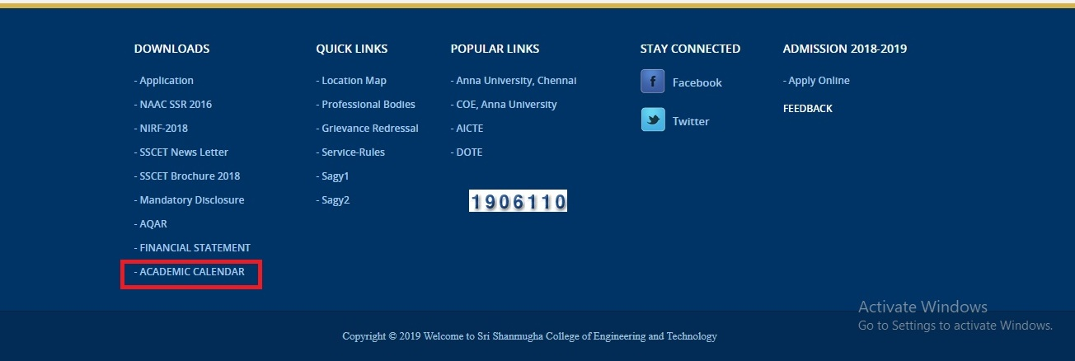

**Academic Time Table:**

**Teaching Load of Each Faculty: As per AICTE/UGC norms**

**Internal Continuous Evaluation system and Place:**

**Yes, completely monitored by Anna University, Chennai**

**Student’s assessment of Faculty, System in Place:**

**Yes, continuous assessment**

**16. Enrollment of Students in the Last 3 Years.**

|  |  |  |  |  |  |  |
| --- | --- | --- | --- | --- | --- | --- |
| Year | B.E - AGRI | B.E - Civil | B.E CSE | B.E ECE | B.E Mech | M.E CSE |
| 2016-17 | 51 | 22 | 55 | 54 | 52 | 2 |
| 2017-18 | 63 | 19 | 49 | 53 | 42 | 0 |
| 2018-19 | 40 | 0 | 50 | 49 | 30 | 6 |
| 2019-20 | 60 | 0 | 42 | 37 | 32 | 2 |

**17. List of Research projects/ Consultancy Works:**

1. **Number of Projects Carried out, Funding Agency, grant Received:**
2. **AICTE – MODROB: 5.2 Lakhs**
3. **AICTE – STTP : 2.9 Lakhs**

**B. Publication (if any) out of Research in last three years out of**

**Masters projects: 6 Publication from referred journals**

**C. Industry Linkage: Annexure- I**

1. **MoUs with Industries (minimum 3):**

**15 MoUs signed for the past Three years**

**18. LoA and EoA till the current academic year**

**LoA: NA**

**EoA: Annexure III**

**19. Account audited statement for the last three years**

